**AIRFORCE SECONDARY SCHOOL**

**END OF TERM 1 ASSESSMENT, 2024**

**S.1 PHYSICS**

**TIME: 1hr 30mins**

***Instruction****; Attempt all questions*

1. Duing the visitation at your school parents and guardians flooded the school compound and as part of the school way of promoting thheir school to the community you are one of the few students selected to show the parents around the school laboratory. Whereas in the laboratory many apparatuses were organized to nbe displayed to the parents and guardians who were eagerly waiting to see how well their learners have attained the knowledge and skills while at school.

**SUPPORT MATERIALS/ RESOURCES**

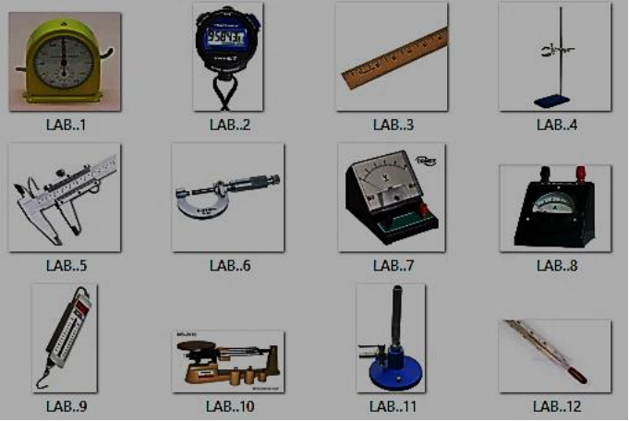

**TASK**

(a) You have been selected as on of the few students to guide parents and guardians through the **Laboratory tour**. Organize the speech you are going to present to the parents about **the physics** **laboratory** and don’t forget to inform them of the rules and regulations they must abide by as they enter the laboratory for the tour.

(b) As the second part of yourpresentation, you are required to organize each apparatus labelled above write down its name and briefly explain its real-life applications.

2. A farmer wants to plant his cabage in a rectangular garden with dimensions of 100m by 50m and he is to use a spacing of 5m between his cabbage trees.

SUPPORT

LAND

50m

100m

**TASK**

(a) Help the farmer to identify the instrument which was used to measure his plot of land and why?

(b) Help the farmer to know the number of cabbage seedlings he would purchase that are enough for his garden.

(c) if 5m2 of land was to cost him Shs. 1500 and one seedling costs Shs. 250, help him to know the amount of money hhe needed.

**END**